Somerset GP Community Pharmacy Consultation Service Stakeholder Toolkit May 2022
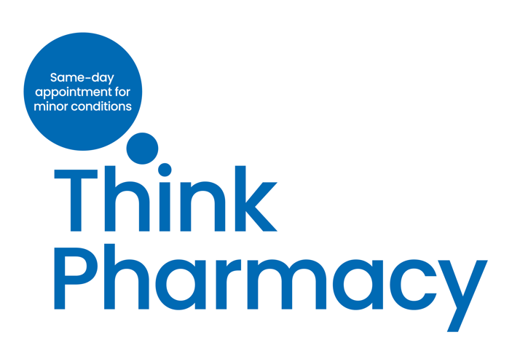
Introduction
After trialling the service last year, in 2022 we have been rolling out the Somerset GP Community Pharmacy Consultation Service which offers patients a same-day appointment with a local community pharmacy of their choice for over 40 minor illnesses and injuries.
Now when a patient contacts their GP in Somerset, after checking that their symptoms would be suitable, a GP receptionist can now offer patients a same-day consultation, by phone or in person, with a community pharmacist of their choice.
To support the rollout of the service, we have been running an awareness campaign with advertising on buses, in local media, at Taunton train station and at supermarkets. As well as running an ongoing social media campaign across twitter, FB, Next door and Instagram.
We have also joined Healthwatch Somerset on their Roadshow to help raise awareness of the service and ask people for their views in terms of whether it is a service they would use.
We have developed a toolkit with information that you can use to promote the service both to your staff and volunteers and externally to the public and your wider stakeholders.
In this toolkit you will find:-
- The campaign graphic
- A news release for your news section on your website
- A news story to go on your website or in any relevant stakeholder newsletters you produce
- Social media graphics for your social media (we use the #ThinkPharmacy hashtag)
- Web banners
- A link to our website page with more information about how the service works
- A link to our survey and a news story asking the public for their views on the new service
- Social media copy for the survey and a link to the survey
- A link to videos about common conditions
- Graphic for stakeholder TV screens
If you have any questions on how to use these campaign materials, or about the service please contact:-
Helen Ashley hashley@nhs.net
Claire Mykura-Aybar claire.mykura-aybar@nhs.net

- Somerset Community Pharmacy Consultation Service campaign graphic
Please use this campaign graphic with the NHS Logo (two variations below)


Other variations of the NHS Logo can be found here….
https://www.england.nhs.uk/nhsidentity/identity-guidelines/nhs-logo/

- A news release to go on your website news page

NEWS RELEASE

May 2022

Summertime sniffles, bites and rashes? Think Pharmacy - a new service launches for quicker treatment of minor conditions in Somerset
A new GP community pharmacy consultation service (CPCS) is being rolled out across Somerset to help patients with a range of minor conditions, such as skin rashes, aches and pains, access quicker treatment via their local community pharmacist.
Patients using the service for minor conditions, are already freeing up approximately 1000 GP appointments every month in Somerset for patients with more complex conditions.
Now, when you contact your GP regarding a minor condition, after discussing your condition, where appropriate, the receptionist will offer you a same day appointment with a community pharmacist of your choice – in person, or over the phone
Community pharmacists have already successfully seen thousands of patients in Somerset for a consultation for a minor condition since the scheme was piloted in Somerset GP practices.
The service is proving particularly popular with parents of toddlers and teens and older people for conditions such as eye and ear infections, sore throats, skin infections, sprains and urinary tract infections and for those with common summer conditions such as hay fever, insect bites and skin rashes and those with sprains and falls.
A minor illnesses or injuries could include:
- Ankle, foot, knee, leg or arm strains and aches
- Bites or stings
- Coughs and colds
- Eye and ear infections
- Hay fever
- Headaches
- Mouth ulcers and blisters
- Rashes
- Skin conditions
- Sore throat
- Urinary Tract Infections (UTI’s)

How the service works
You will be contacted by your nominated community pharmacist to arrange any appointment for a consultation in person or on the phone. When you have a consultation for a minor condition, your pharmacist will take your medical history, ask about your symptoms and any current medication you might be taking. Following the consultation, they will offer you clinical advice and if appropriate, offer you an over-the-counter product. Increasingly pharmacies can also prescribe medication such an anti-biotics and are often open at evenings and weekends. The pharmacist will make a record of the outcome of your consultation and send it to your GP.
If having given you advice or treatment, your pharmacist thinks you may need further specialist help they will be able to refer you back to your GP or recommend another health service for support.
Dr Jeremy Imms, Associate Clinical Director, Somerset Clinical Commissioning Group, said: “The Somerset Community Pharmacy Consultation Service will be of huge benefit to many of our patients as lots of minor conditions are more appropriate for a consultation with a community pharmacist, rather than a GP.
“This will improve access for patients with minor illnesses and will also help us to free up GP appointments for people with more complex health needs; helping ensure everyone gets treated at the right time, by the right healthcare professional.
“At this time of year people are beginning to experience seasonal conditions, such as hay fever, insect bites and rashes, and more sporting and other minor injuries from just being outdoors more. Our community pharmacists are highly experienced in diagnosing and treating common complaints, and patients will now the ability to choose to have their consultation with a pharmacy close to home at a convenient time.”
Michael Lennox, CEO of Community Pharmacy Somerset, said: “Community Pharmacists are highly trained healthcare professionals with five years training and spend a high percentage of their time helping treat patients with minor illness and recommend over-the-counter treatments where necessary.
“Pharmacies across the area are often open during evenings and throughout the weekend and can provide support on the same day via the phone, with most having rooms available for a private consultation.
“As well as saving you time, getting support from your community pharmacist frees up appointments for your GP to see more urgent patients. If we think you do need to see a GP, we’ll always advise you to do so.”
Find out more about the community pharmacist consultation service (CPCS), answers to frequently asked questions and a short animation at: https://www.somersetccg.nhs.uk/community-pharmacy/
ENDS

Notes to Editors
- For more information, please contact:
Communications Team at Somerset CCG Somccg.communications@nhs.net

- Graphics and animations for the Think Pharmacy campaign are available.

- Please let us know whether you would like to interview a GP or community pharmacist in relation to this story.

- A news story to go on your website or in any relevant stakeholder newsletters you produce
If you live in Somerset and contact your GP to discuss a minor illness or injury, your GP receptionist may offer you a same-day consultation with your community pharmacist through the Somerset GP Community Pharmacy Consultation Service .
Your community pharmacist can offer clinical advice and over the counter products and medications for over 40 minor illnesses and injuries including eye and ear infections, sprains and aches, hay fever, skin conditions and urinary tract infections.
Community pharmacists are highly qualified clinicians and can offer medical advice for minor injuries and illnesses.
During your consultation, your pharmacist will take your medical history, ask about your symptoms and any current medication you might be taking.
Following the consultation, they will offer you advice and where appropriate, offer you an over-the-counter product. Some pharmacists are also able to offer anti-biotics.
The pharmacist will make a record of the outcome of your consultation on your patient record.
If having given you advice/treatment, your pharmacist thinks you may need further specialist help they will be able to refer you back to your GP or recommend another health service for support.
Since the service was rolled out across Somerset from January, patients using the service have freed up around 1000 GP appointments every month for patients with more serious/complex conditions.

- Social media graphics for your social media (we use the #ThinkPharmacy hashtag)
 | Text for social media | Images to use
General | If you live in Somerset and contact your GP to discuss a minor illness or injury, your GP receptionist may offer you a same-day consultation with your community pharmacist.  Find out more: https://bit.ly/3iJtgd2 |   Download here
Families | Being a parent isn't always easy but getting medical help for your child is.  Now if you contact your GP about your child’s minor illness or injury, you may be offered a same-day appointment with a pharmacist.  Find out more: https://bit.ly/3iJtgd2 | 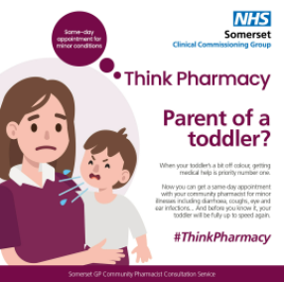  Download here
Hay fever | Don’t let itchy eyes and a runny nose ruin your fun this summer.  Now if you contact your GP about your hay fever, you may be offered a same-day appointment with a pharmacist of your choice.  Find out more: https://bit.ly/3iJtgd2 | 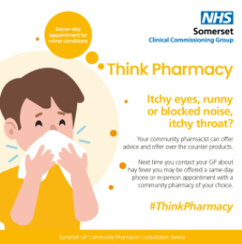  Download here
Aches and pains | Joint or muscle pain that won’t go away? Don’t let it get worse.  Now you can get a same-day community pharmacy appointment for minor conditions and injuries via your GP.  Find out more: https://bit.ly/3NlBshX | 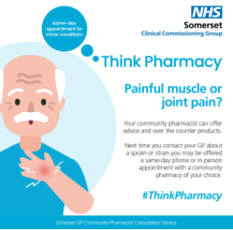  Download here
Insect Bites | Don’t let insects ruin your buzz this summer. Bites and stings can often be sore, itchy and swollen.  Now you can get a same-day community pharmacy appointment for minor conditions and injuries via your GP.  Find out more: https://bit.ly/3NlBshX | 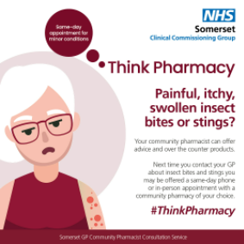  Download here
Eye Infection | Eye infections, also known as Conjunctivitis, can make your eyes red, feel gritty and itch.  In Somerset, next time you contact your GP about a minor eye infection, you may be offered a same-day consultation with a local community pharmacy of your choice.  Find out more: https://bit.ly/3iJtgd2 | 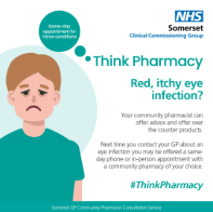  Download here

---------------------------------------------------------------------------------------------------------------------

- Web Banner graphics for your website

Web Banner 1 |   Download here
Web Banner 2 |  Download here

- A link to our website page with more information about how the service works https://www.somersetccg.nhs.uk/community-pharmacy/

- News story about our survey asking the public for their views on the new service
If you have used our new Somerset GP Community Pharmacy Consultation Service, where you are offered a same day appointment via your GP with a local pharmacist for minor illnesses and injuries. Or if you haven’t used the service but would like to give us feedback on whether it’s something you would use, we would like to hear from you.
You can still share your views by completing our online questionnaire. Deadline for responses 23 May 2020.

- Social media for patient survey
Below is the copy for social media posts to go with the link to the patient survey about the GPCPCS survey

Copy:

💡Would you like to have your say on our new Somerset GP Community Pharmacy service offering same day appoints via your GP for over 40 minor conditions ?

🧐Has your GP referred you to a community pharmacy when you've contacted them about a minor health condition or injury?

👋Our team have a short survey to ask whether it’s a service you would be interested in using. Or to share your experience if you’ve used the service.

👋Make sure you share your views by the 23 May here: https://bit.ly/3spsEyD

Twitter:  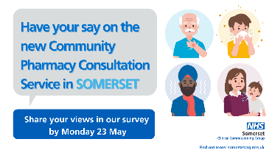  Download here | Instagram:  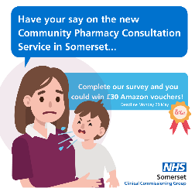Download here | Facebook:  Download here | Stories:  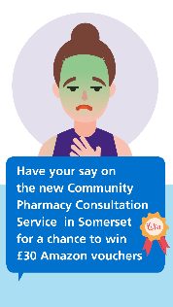Download here

-----------------------------------------------------------------------------------
- A link to our videos to promote how the service can help with common minor conditions
https://www.youtube.com/playlist?list=PLi6ujK3K5OHr0nwq-d0kuqxKXKksyQctY

- Graphic for GP/Stakeholder TV screens
Graphic for stakeholder TV Screens | 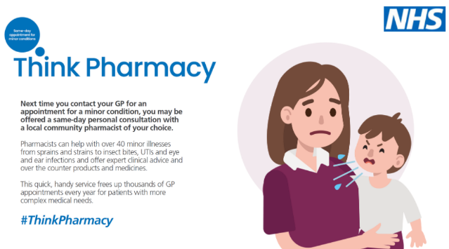  Download here

